Unit 4 test
Vocabulary
Vocabulary
1 Look and tick ().
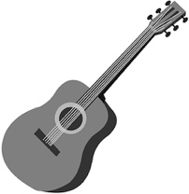 | 1 A ☐ guitar  B ☐ video game
 | 2 A ☐ trophy  B ☐ bracelet
 | 3 A ☐ helicopter  B ☐ puppet
 | 4 A ☐ watch  B ☐ poster
/ 4
2 Look, read and number.
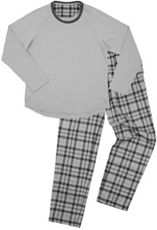 | 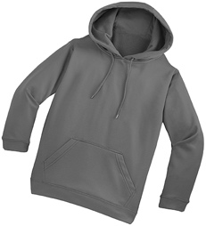 | 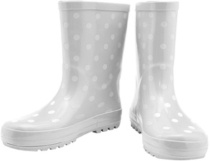 |  | boots  coat  hoodie  jeans  pyjamas  sandals
1 | 2 | 3
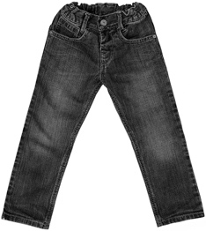 | 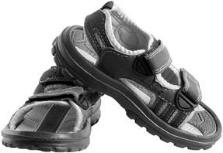 | 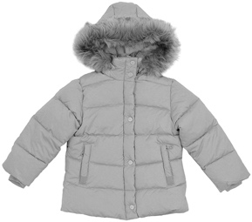
4 | 5 | 6
/ 6

Grammar
3 Read and tick ().
1 Whose helicopter is this?
It’s your helicopter. It’s … .
A ☐ yours B ☐ mine
2 Whose watch is this?
It’s my watch. It’s … .
A ☐ mine B ☐ yours
3 Whose trophy is this?
It’s Emma’s trophy. It’s … .
A ☐ theirs B ☐ hers
4 Whose poster is this?
It’s Tang’s poster and it’s May’s poster. It’s … .
A ☐ theirs B ☐ hers
5 Whose puppet is this?
It’s Omar’s puppet. It’s … .
A ☐ ours B ☐ his
6 Whose guitar is this?
It’s my guitar and it’s your guitar. It’s … .
A ☐ his B ☐ ours
/ 6
4 Look, read and match. What are you wearing?
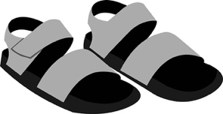 | 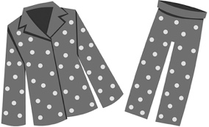 | 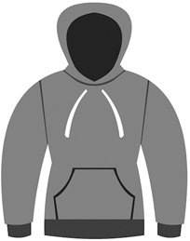 |  | I’m wearing …  boots.  a hoodie.  sandals.  jeans.  pyjamas.
1 | 2 | 3
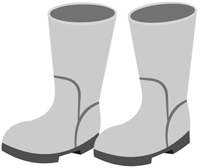 | 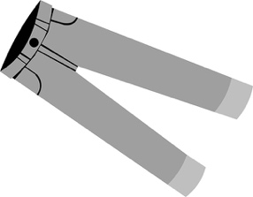
4 | 5
/ 5
Reading
5 Read and complete with one word.
My favourite thing!
by Priti
I’ve got a puppet from Sydney, Australia. Sydney is my favourite place, and this puppet is my favourite thing! My puppet’s name is Skippy. He’s a kangaroo!
He’s wearing red shorts. He’s wearing green sandals, too. Skippy’s clothes aren’t paint. They’re material! You can see lots of puppets like Skippy in Australia.
My brother’s favourite thing is a doll from Italy. It’s a football player. It’s wearing a blue football shirt. What’s your favourite thing?
1 Priti’s is from Australia.
2 Skippy is wearing shorts.
3 Skippy is wearing green .
4 Priti’s has got a doll.
5 The doll is wearing a football shirt.
/ 5
Writing
6 Rewrite the sentences.
1 The puppet is wearing trousers a shirt a hat.

2 I’ve got a poster a watch a doll.

3 I like my hoodie boots jeans.

4 Their names are Sam Eva Tom Sue.

/ 4

Listening
7  4 Listen and circle the tick () or the cross ().
 |  | 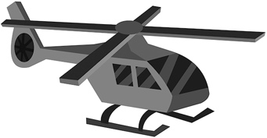
1 / | 2 / | 3 /
 | 
4 / | 5 /
/ 5
Speaking
8 Look, read and answer.
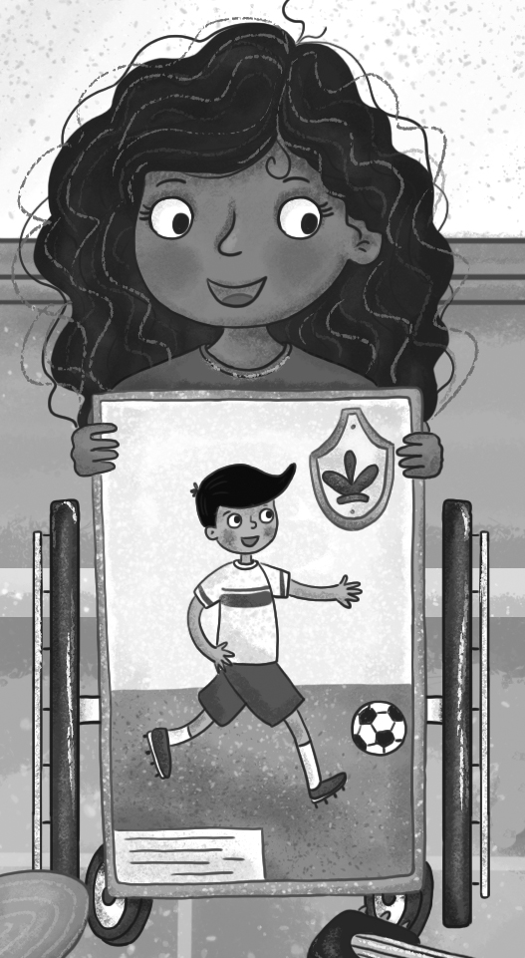
1 What’s her favourite thing?
2 What’s in the poster?
3 What is he wearing on his body?
4 Has he got a ball?
5 What’s your favourite thing?

/ 5
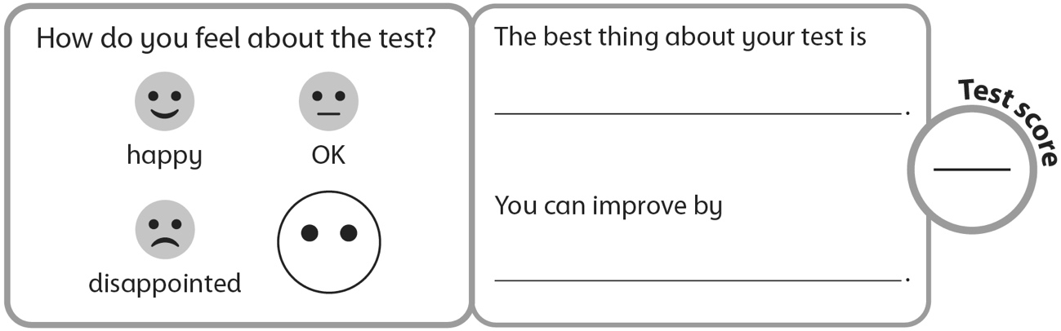
40

